Student Name: Yuyang Gong Student Number: 49079984 Team Name: FriendZone
Week: 9 to 10
Title: Evaluating the Prototype and Changing Direction

Description:
We evaluated the prototype with four anonymous participants using task-based questions and the System Usability Scale. The average SUS score was 63.1, with scores ranging from 20 to 90. Conversation prompts were consistently the strongest feature, while the NFC workflow, timer and leaderboard were confusing or unclear for some participants.
Privacy and pressure were major concerns. Participants questioned what interaction data would be stored, who could see it and whether time together represented meaningful connection. Public ranking also felt competitive. Based on these findings and later research, we decided to retain the phone-down and prompt concepts while replacing the leaderboard with a friend relationship map that visualises connections without ranking people.
Visual Evidence:
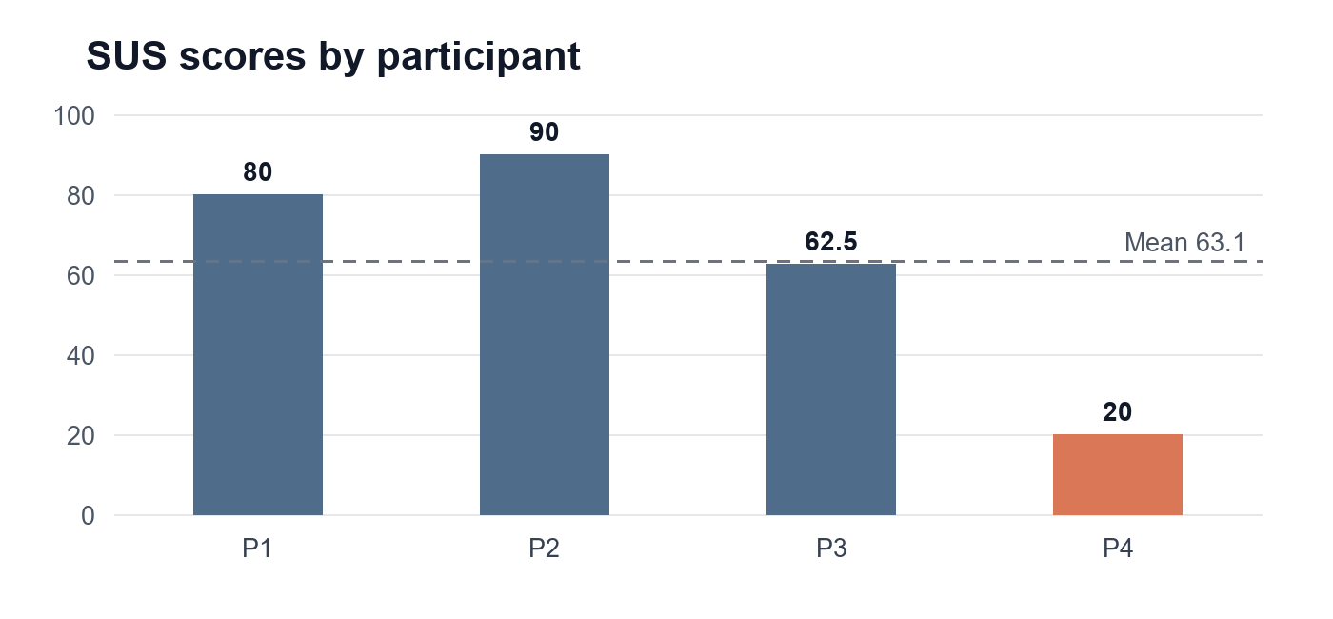
System Usability Scale scores from four prototype participants, showing substantial variation.
Statement on Learning:
I learned that usability and social acceptability are different. A person may understand a feature and still reject its values or emotional effect. The next prototype should explain consent and data visibility, make prompts contextual and optional, and test a non-competitive relationship map on mobile devices with moderated observation.

